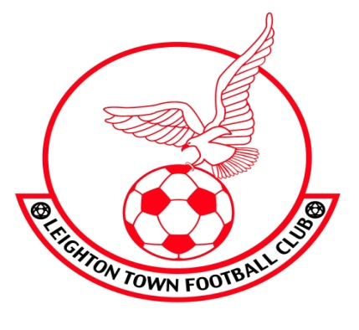
APPLICATION FORM FOR LEIGHTON TOWN/LEIGHTON TOWN YOUTH: U18 TRIALS
SATURDAY 23 MARCH 2019 AT CEDARS UPPER SCHOOL
(Please complete in capital letters)
Name
Date of Birth
Address

Contact number
Current club
Preferred position
Alternative position
Representative honours/experience

Please email your return to Sean Downey at downeys@vandyke.cbeds.co.uk
Alternatively attend our ‘Meet and Greet’ event on Saturday 16 March at 1-00pm at Leighton Town
With thanks
Sean Downey Mark Horne
Director of Football Youth Development Liaison Manager
Leighton Town FC Leighton Town FC

Leighton Town FC, Bell Close, Lake Street, Leighton Buzzard, LU71RX

